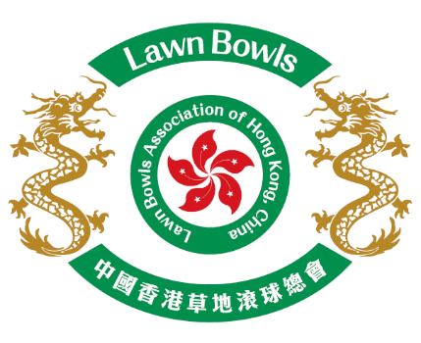
Lawn Bowls Association of Hong Kong, China

Recruitment of Coaching Team Staff
(Non-Contract Part Time Employment)
for Hong Kong, China Squad 2026-2027

Application Form

Post applied* : | □ Head Coach |  | □ High Performance Manager
 | □ Assistant Coach
Name in English : (As in HKID) |  |  | Name in Chinese :
H.K.I.D. No. (First 4 digits): |  |  | Gender :
Year of Birth :
Occupation :
Tel.No. : | (Office) : |  | (Fax) :
 | (Home) : |  | (Mobile) :
Email Address :
Residential Address :
Do you have Driving License? | Yes |  |  | No
Coaching Qualifications (Please tick one) : | □ LBA Level I | □ LBA Level II |  |  |  | □ LBA Level III
Coaching Qualifications (Please tick one) : | □ HKCC Level I | □ HKCC Level II |  |  |  | □ HKCC Level III

Coaching History and Achievements :
Playing History and Achievements :
Other Relevant Professional or Academic Qualifications :

Language: (please put fluent, good, moderate or basic under each box below)
English |  | Chinese
Written | Spoken | Written | Spoken Cantonese | Spoken Putonghua
Microsoft Office Skills or Equivalent
□ MS Word | □ MS Excel |  |  | □ Other:
Awareness/knowledge of child protection in sport and equal opportunity issues in the context of Hong Kong * :
□ Yes No
□ I hereby confirm that the above information is correct.
*Please  the appropriate box(es).

Signature:  Name: | Date:
FOR OFFICE USE ONLY
Received on : | Handled by :
Remarks :

