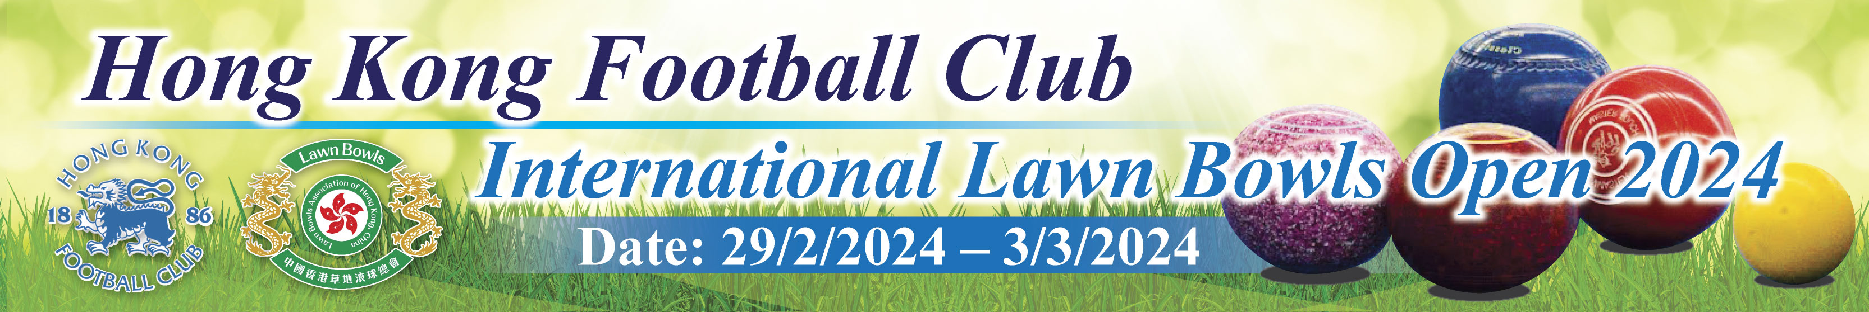
Hong Kong Football Club International Lawn Bowls Open 2024
Aim: To host an International event in promoting the sports of lawn bowls in Hong Kong; and to foster the relationship with the member clubs of Lawn Bowls Association of Hong Kong, and friendly clubs throughout China, Asia etc.
Event Day: 29th February 2024 Thursday to 3rd March 2024 Sunday
Venue: Indoor and Outdoor Green, HKFC
_____________________________________________________________________
Program One - Unisex Triples:
Date: 29.2.2024 Thursday and 1.3.2024 Friday
Number of entries: 48 Teams (Divided into eight groups)
The first of each group will enter into cup finals, and the second of each group will enter into the plate finals.
Enrolment fees: HK$2,700 per team of 3 players, HK$ 600 for 1 additional player (Including Buffet Lunch on 1.3.2024, 2 Event Polo Shirts, drinks and snacks after the prize presentation)
Each Team can register up to 4 players but no change of members is allowed once the enrolment is accepted.
Prize Money: HK$28,800 for Cups Finalists, HK$14,400 for Plates Finalists

Program Two - Unisex Fours:
Date: 2.3.2024 Saturday and 3.3.2024
Number of entries: 48 Teams (Divided into eight groups)
The first of each group will enter into cup finals, and the second of each group will enter into the plate finals.
Enrolment fees: HK$4,000 per team of 4 players, HK$ 750 for 1 additional player (Including Buffet Dinner on 3.3.2024, 2 Event Polo Shirts)
Each Team can register up to 5 players but no change of members is allowed once the enrolment is accepted.
Prize Money: HK$48,000 for Cups Finalists, HK$24,000 for Plates Finalists
___________________________________________________________________________

Enrolment period: 13th November 2023 to 10th December 2023
Enrolment should sent to the below e-mail
hkfc.lawnbowlsopen@gmail.com
Payment: Payment should be made when you are informed that your enrolment is accepted, and the deadline is 31st December 2023
*Please deposit the correct amount into the HKFC Club Account
HSBC A/C No. 002-220606-001
Enclosure: The competition format, conditions of play and the enrolment form are given in the attached files

Should you need further information, please free feel to contact Mr. Philip CHAN at 9511 6788 or by e-mail gtf1968@hotmail.com

With Best Regards,
Johnny TSANG
Chairman, Lawn Bowls Section, Hong Kong Football Club

